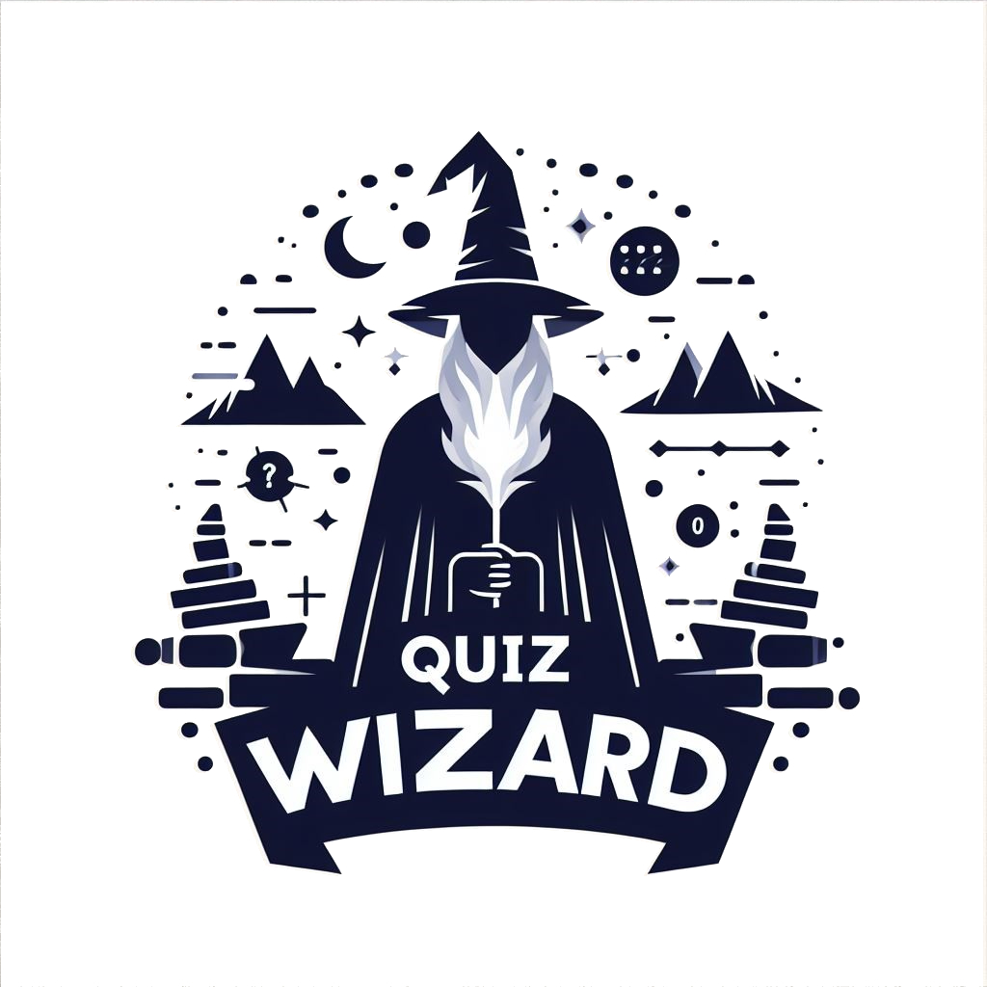

QUIZ WIZARD

Quiz Wizard

Quiz Wizard

## Declaration

I hereby declare that the project work entitled Quiz Wizard submitted in partial fulfilment of the award of class 12 under the AISSCE 2023-20214 scheme in Computer Science is a bonafide record of the research carried out by me under the guidance of ***Mrs. Brighty Varghese***, ***Mrs. Jincy Swarup*** and ***Mrs. Soby Susan Babu*** and no part of it has been submitted for any other study.

**Name: Signature:**

## Acknowledgement

*First and foremost, I thank Lord Almighty for giving me this thought…*

*I am happy to express my profound sense of gratitude to Rev. Fr. Scaria Ethirett CMI, Principal, Placid Vidya Vihar for the encouragement he gave me throughout the course especially in the successful completion of this study. I am deeply indebted to my computer teachers Mrs. Brighty Varghese, Mrs. Jincy Swarup and Mrs. Soby Susan Babu for their valuable guidance and support which has been an indispensible factor in the successful completion this work.*

*I wish to express my special thanks to all the teachers and the laboratory staff of Placid Vidya Vihar, Changanassery.*

*I wish to express my sincere thanks to my parents and friends who rendered timely help and extended gracious cooperation throughout my work.*

## Contents

|  |  |  |
| --- | --- | --- |
| ***Sl.no*** | ***Content*** | ***Page no:*** |
| 1 | Introduction | 05 |
| 2 | Python and MySQL Review | 06 |
| 3 | Method Description | 08 |
| 4 | System Specification | 09 |
| 5 | Flow Of Control | 10 |
| 6 | Source Code | 11 |
| 7 | Output | 19 |
| 8 | Conclusion | 23 |
| 9 | Bibliography | 24 |

Introduction

The "Quiz Wizard" is an innovative project designed to serve as a study

companion, making the learning process both enjoyable and engaging. With a unique set of features, Quiz Wizard aims to create a personalized user experience by allowing players to create individual profiles and maintain their quiz scores.This facilitates healthy competition and encourages continuous improvement.

Key Features of Quiz Wizard:

1. Play Quiz: Users can actively participate in quizzes created by others, broadening their knowledge and gaining valuable insights.

2. Score Board Viewing: The platform will maintain a record of high scores achieved by players, offering a sense of accomplishment and fostering healthy competition among users.

## Python and MySQL Review

### **Python**

Python is an open-source, object oriented, high-level programming language. The main features or Advantages of Python are:

→ ***Platform Independent:*** It can be run across different platforms like Windows, Linux, Mac OS etc.,

→ ***Readability:*** It is easy to read and understand as it has English-like structure.

→ ***Object Oriented Language:*** It is an interactive interpreted and Object-oriented language

→ ***Ample Availability of Libraries:*** It provides large standard libraries to solve a task

→ ***GUI Programming:*** Python supports GUI programming.

→ ***Dynamic Typing:*** Variable declaration is done automatically by the interpreter.

→ ***Extensible, Extendable and Highly Efficient***

→ ***Supports Garbage Collection:*** It has better memory management.

→ ***Easily Compatible with other programming languages like C++, Java etc.,***

→ ***Saves Time:*** Due to the availability of high-level datatypes and its dynamic typing feature.

### **MySQL**

MySQL is an open source and freely available Relational Database Management System (RDBMS) that uses Structured Query Language (SQL). It provides excellent features for creating, storing, maintain and accessing data, stored in the form of databases and their respective tables.

Features of MySQL are:

→ ***Ease of Use:*** It is very easy to use.

→ ***No coding Required:*** It is a non-procedural and a unified language.

→ ***Portable:*** It is compatible with other database like Dbase IV, FoxPro etc.

→ ***Reliable:*** SQL provides a high level of well-defined commands that provide desired results without any ambiguity.

→ ***Large Volume of Data can be stored.***

→ ***MySQL is not case sensitive.***

→ ***Powerful Language.***

→ ***Freedom of data abstraction.***

### **Python – MySQL interface**

Python – MySQL connectivity enables one to implement the MySQL Client/Server protocol automatically in Python. The interface is

→ ***Platform- independent***

→ ***Faster and More efficient***

→ ***Portable***

→ ***Easy to migrate and port database application interface.***

→ ***Python support MySQL cursors***

→ ***It handles Open and Closed Connections***

## Method Description

Quiz Wizard is a sophisticated Graphical User Interface (GUI) study companion meticulously designed to empower students in their learning journey through engaging quizzes. Tailored for a diverse range of subjects, Quiz Wizard offers a comprehensive platform to augment the learning experience.

With Quiz Wizard, students have the opportunity to select from an array of subjects, unlocking a dynamic realm of knowledge. These thoughtfully curated quizzes serve as a conduit for deeper comprehension, encouraging active participation and retention.

The intuitive interface of Quiz Wizard ensures seamless navigation, providing a user-friendly experience for learners of all levels. Whether delving into mathematics, literature, or the sciences, Quiz Wizard remains a versatile tool adaptable to various academic disciplines.

**This Project Contains:**

* ***Main menu:*** Each student can select between playing the quiz or viewing the leaderboard.
* ***Play quiz:*** Students can select a quiz of their choice from an array of subjects.
* ***Leaderboard:*** Students can view their score and compare their progress among peers.

The program uses the modules :

1)Colorama

2)termcolor

3)time

## System Specifications

#### Hardware

* Processor : Intel Core i3
* Memory : 4GB RAM

#### Software

* + Operating System: Windows 10 HOME 64 bit
  + Programming Language: Python 3.7
  + Database : MySQL 5.7

Flow of Control

Main Menu

Exit

Play quiz

View Score Board

Check if new player

No

Yes

Create new player id player

Quiz Gameplay

Save quiz and update score

# SOURCE CODE

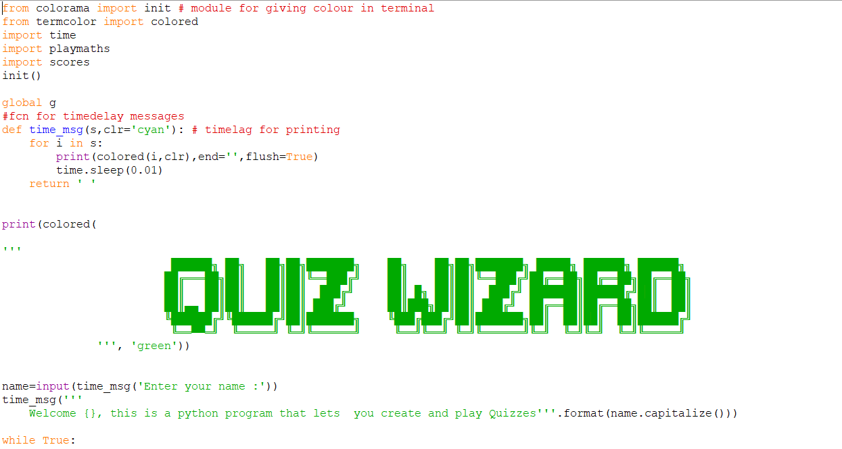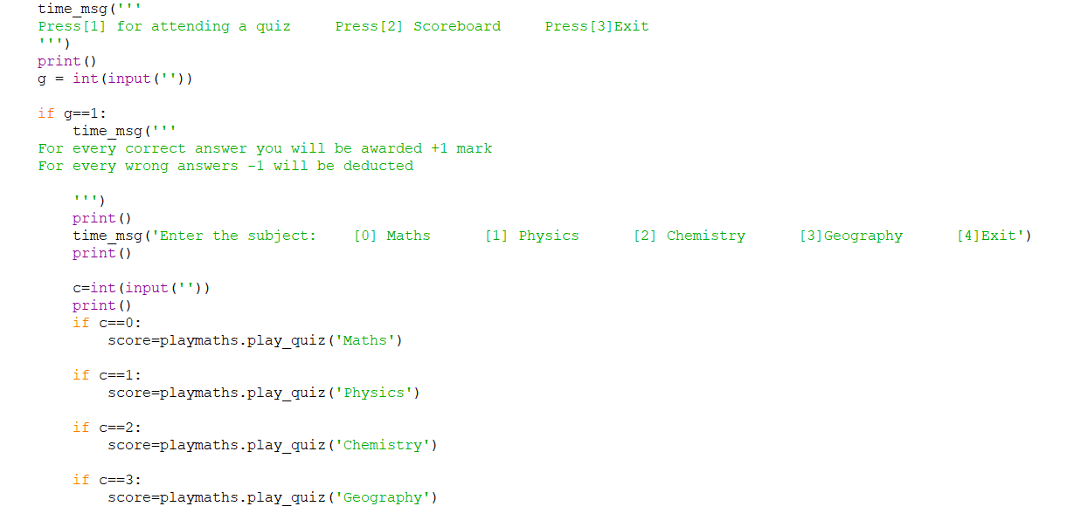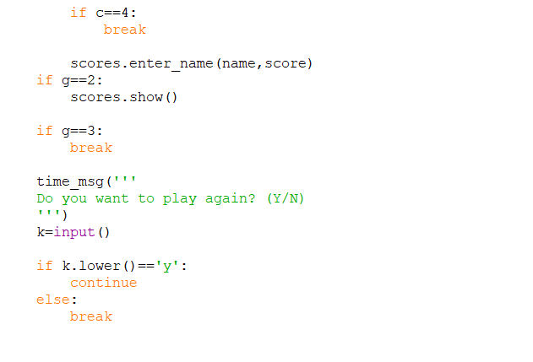

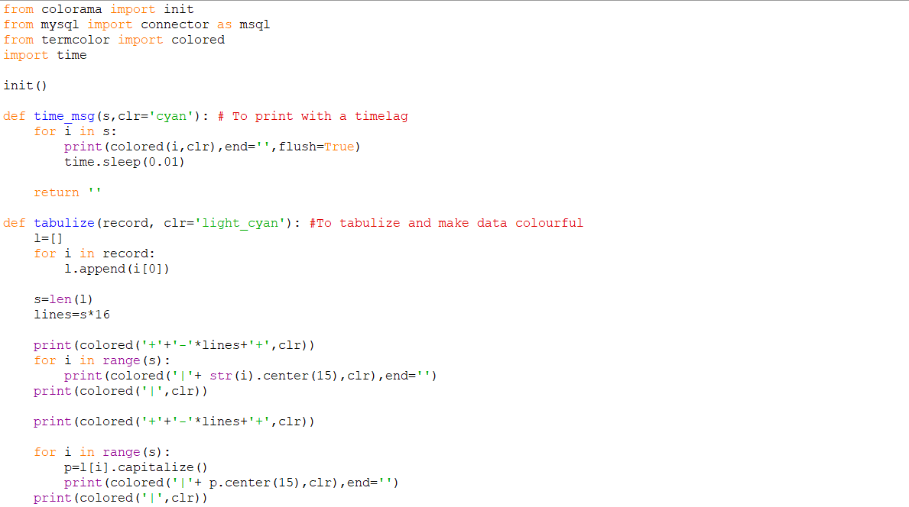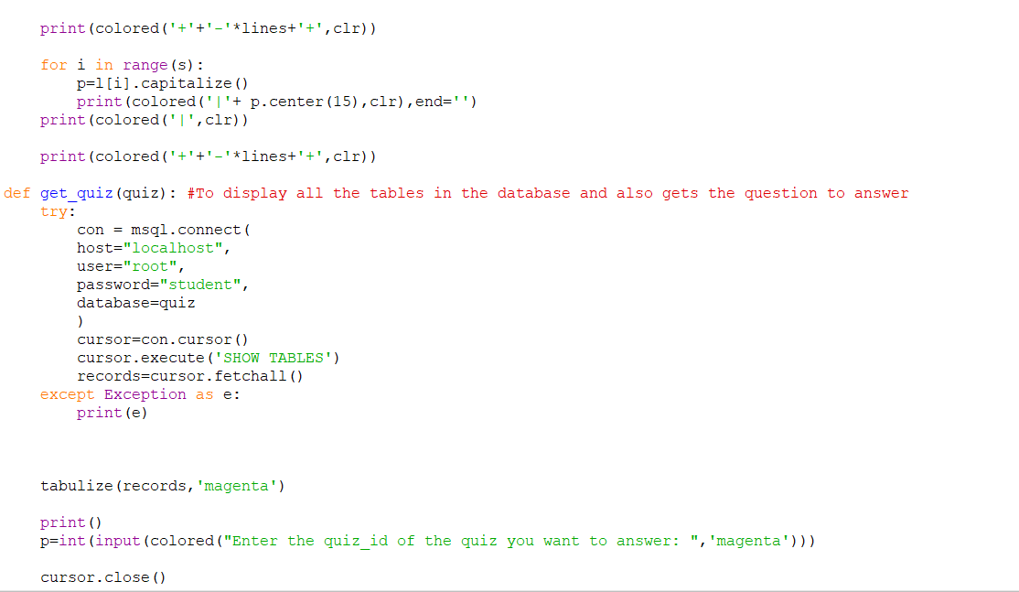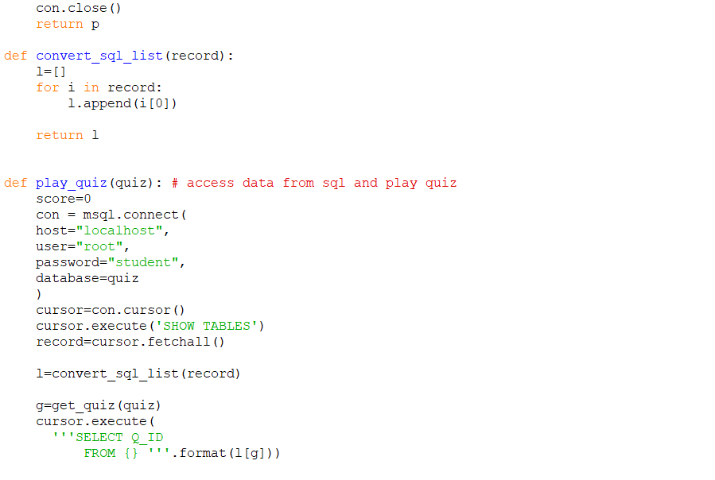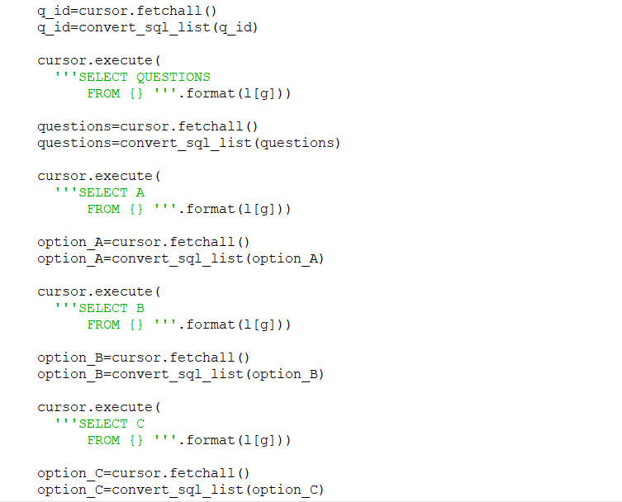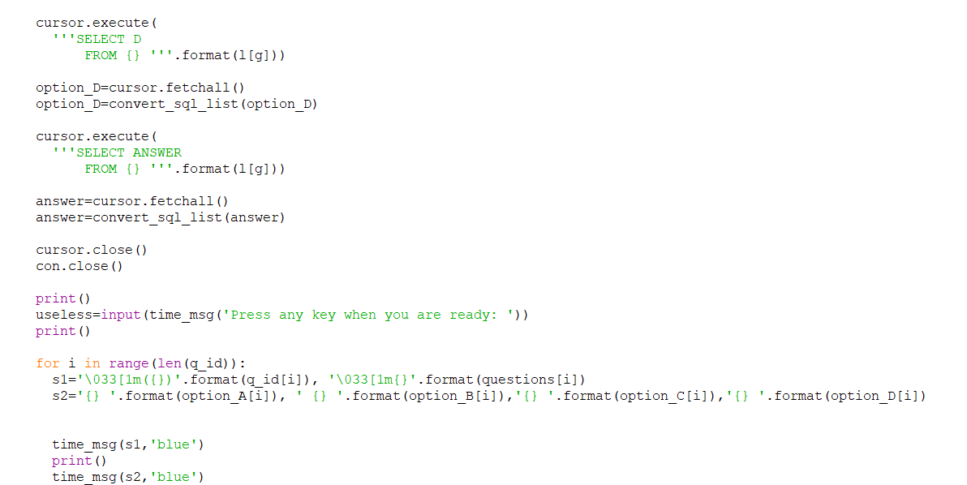

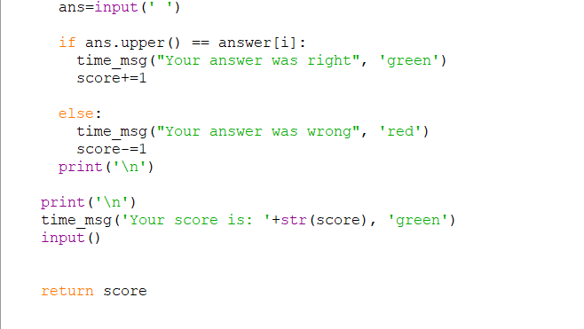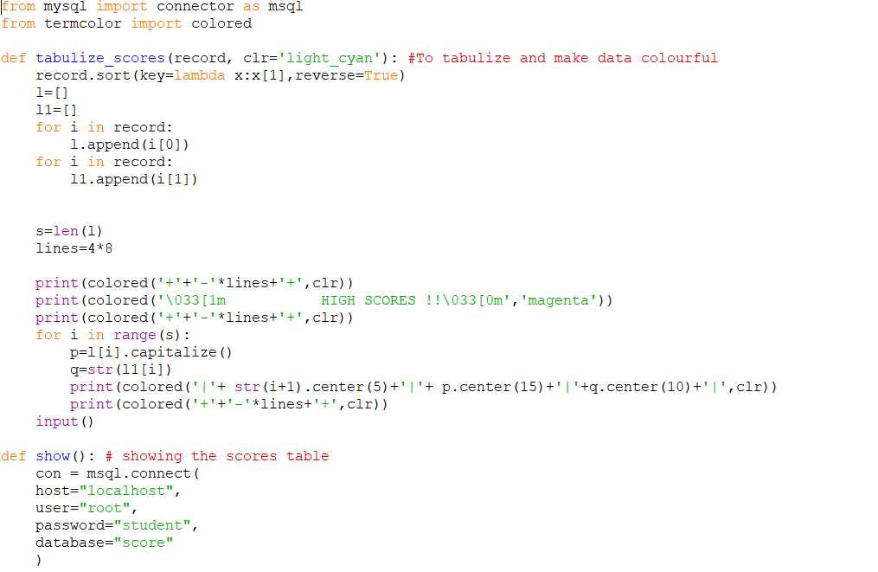

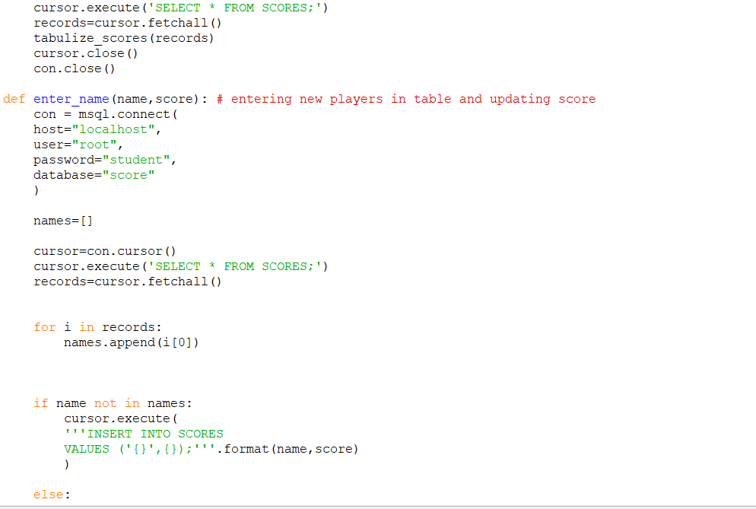

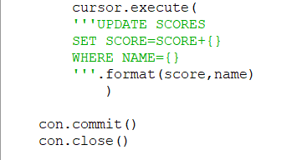

# Output

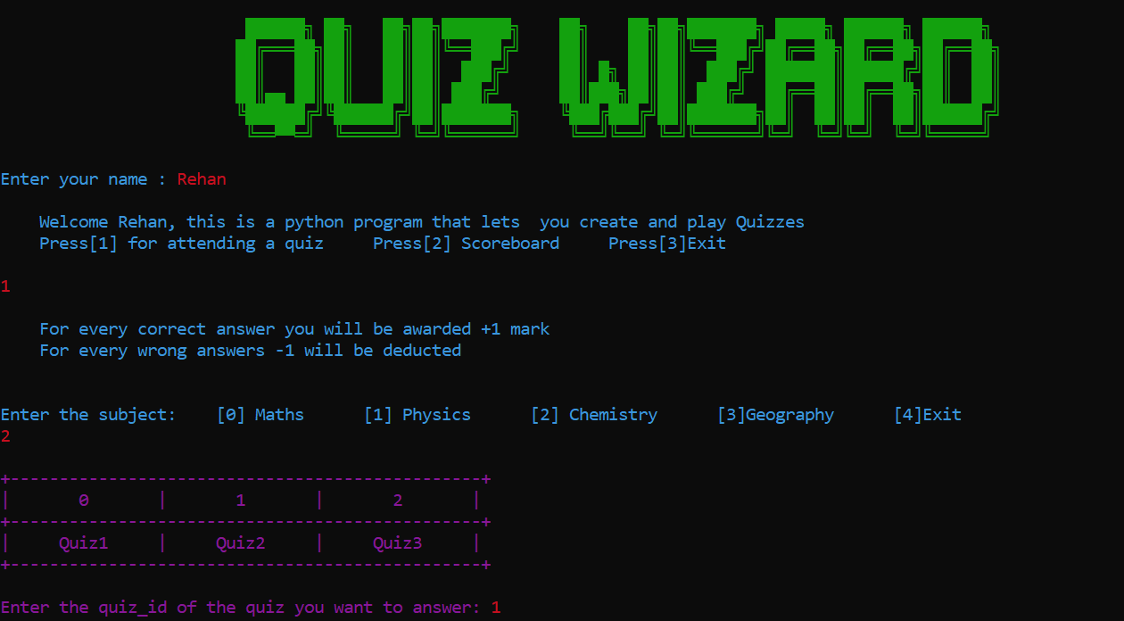

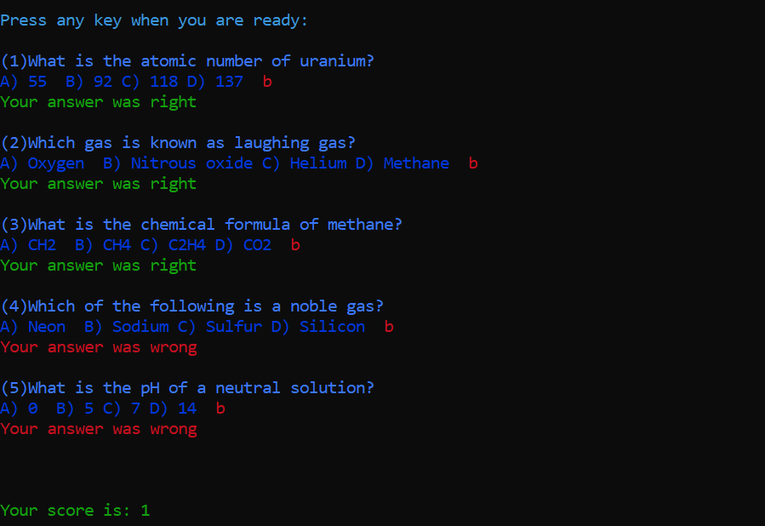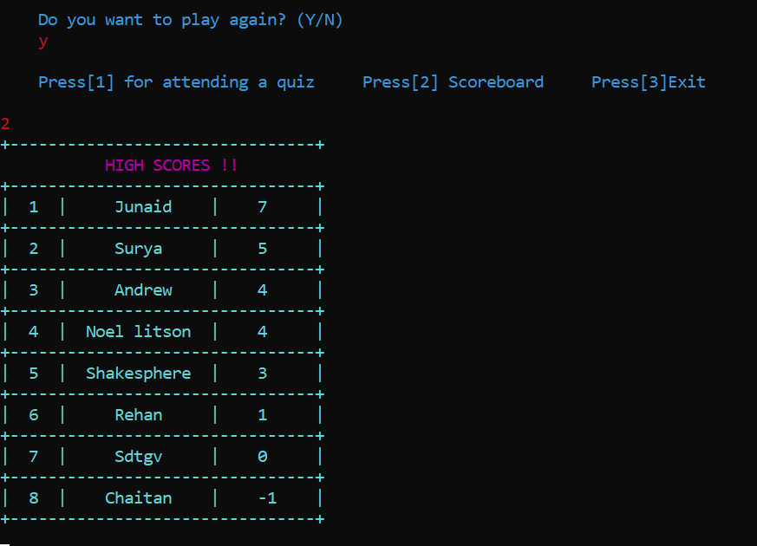

Conclusion

By this project, we were able to learn a lot about quiz creation programs and Python – Mysql inteface concepts. This project has helped us to get a deeper knowledge of the Python programming language. We believe that we have made use of our knowledge in python to make this project a success. This program was compiled and rectified of all errors. It was run and the desired output was obtained.

## Bibilography

* Computer Science with Python *by Preeti Arora*
* NCERT XII Computer Science textbook
* [www.geeksforgeeks.com](http://www.geeksforgeeks.com)
* [www.w3schools.com](http://www.w3schools.com/)
* [www.wiki.python.org](http://www.wiki.python.org/)

**Thank You**

**Page 24 of 24**

Page **50** of **50**